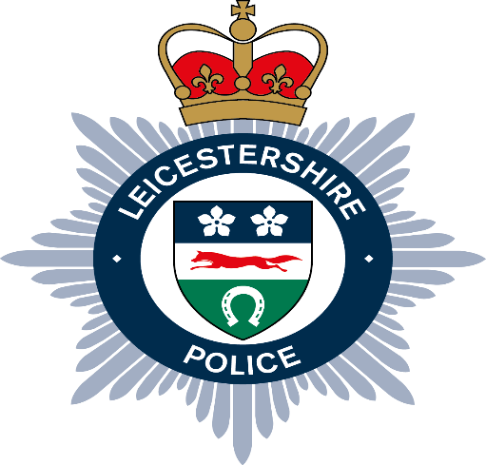
Local Independent Advisory Group (LIAG)
Northwest Leicestershire

The second Northwest Leicestershire LIAG meeting was held on the Wednesday 16th July 2025 at 19:00 hours at the Coalville Police station.
Seven members were in attendance.
They discussed a range of topics, including the force use of GoodSam technology, supporting the team Leicestershire Academy and the most recent identified local neighbourhood priorities.
No further business was raised.

