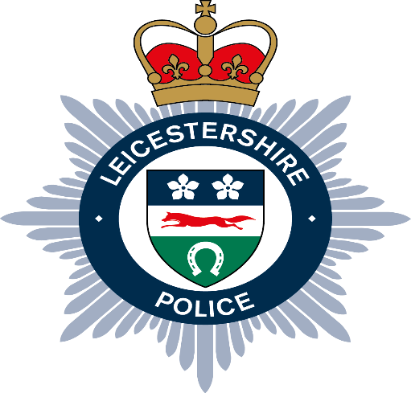
Local Independent Advisory Group (LIAG)
South Leicester

The South Leicester LIAG meeting was held on Wednesday 28th July 2025 at Euston Street Police Station.

Four members were in attendance including a new member.

The group discussed the current group membership, including the selection of a new vice chair. The Chair gave a summary update of the Strategic Independent Advisory Group (SIAG).

A presentation on ‘GoodSam’ was delivered to provide an insight into new technology the force had implemented. The group discussed the positives and some areas of concern whereby reassurance was offered.

The group also discussed the advantages of perhaps sharing contact details with the other 8 LIAG groups across Leicester, Leicestershire & Rutland.

Finally, the group discussed upcoming events and engagement events inviting local officers to be part of.

